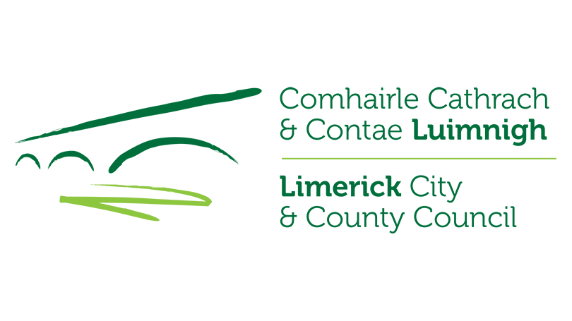


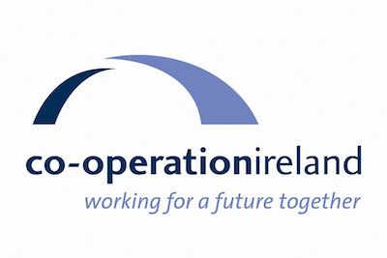


Pride of Place Competition 2026
Expressions of Interest Form

Limerick City and County Council invite expressions of interest from local community groups who wish to seek nomination to the 2026 IPB Pride of Place Competition in association with Co-operation Ireland.
Please enter the required details below:
- What competition (select either A or B) and category (select from list below relevant competition) are you interested in entering?

- Main Competition Category:
Category | Population
1 | 0 - 300
2 | 300 – 1,000
3 | 1,000 – 2,000
4 | 2,000 – 5,000
5 | Population Over 5,000
Category | Theme
6 | Creative Communities
7 | Climate Action and Biodiversity
8 | Community Youth Initiative
9 | Inclusive Communities
10 | Community Wellbeing Initiative
11 | Community Tourism Initiative
12 | Age Friendly Communities
13 | Urban Neighbourhoods / Housing Estates

Or

- Cities Competition Category:
Category | Population
1 | Urban Neighbourhoods/Village under 3,000
2 | Urban Neighbourhoods/ Village over 3,000
Category | Theme
3 | Creative Communities
4 | Climate Action and Biodiversity
5 | Community Youth Initiative
6 | Inclusive Communities
7 | Community Wellbeing Initiative

- Community Group Name:

- Community Group Contact Person:
Name:

Contact Number(s):

Email Address:

- Area / Location Represented by Group: (i.e. locality/townland)

- Length of time in existence:

- Entry Summary:
To ensure that your community gets the best possible profile please take a little time to compose a summary detailing your group/ community and its activities.
Each summary (maximum 160 words) should include details of the area represented or group represented, the county, a short description of location, and a short history and details of current activities.
- Maximum 160 words written as a paragraph in the third person.
- No Lists, no personalities (named personages), no unexplained acronyms
See below 2023 example summary:
“Killeedy, Cill Íde, the home place of St Ita, is a small rural parish nestled at the foot of the magnificent Mullaghareirk mountains that form the border between West Limerick and North Cork. It has two villages, Raheenagh and Ashford, at either end of the parish and Kantoher Enterprise Park at its centre. A very vibrant community, it has twenty different voluntary bodies all working together creating a caring environment with health, well-being, and quality lifestyle to the fore.
Following a major setback in 2005 with the closure of Kantoher Co-op and the loss of over 350 jobs Kantoher Development Group was set up and, with the help of numerous state bodies and local input, there are now 14 new companies based at Kantoher Enterprise Park employing over 200 people. The old Ashford Tavern has been refurbished and Killeedy Eco Park, a 13-acre outdoor facility that includes an Integrated Constructed wetland, was opened in 2020.”
Please write your summary here (160 words maximum):

- Entry Photograph:
Please ensure to attach a recent photograph of your entry.

Please complete and return, preferably by email to: prideofplace@limerick.ie

Or by post to: Pride of Place Liaison Officer
Community Development Department
Limerick City and County Council
Merchant’s Quay
Limerick
V94 EH90

Closing date for receipt of expressions of interest is close of business on
Friday, 24th April 2026.

