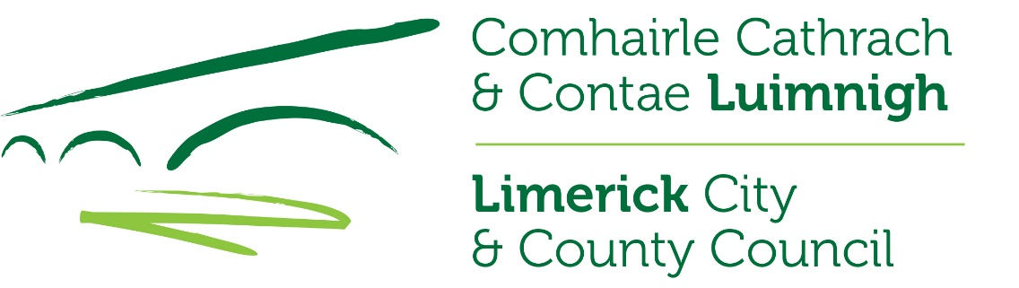

Claim form – Domestic Lead Remediation Grant Scheme
- Details of the applicant
Name of applicant (in BLOCK):
Address (location of property):

Eircode:
Daytime telephone No:
E-mail address:
- General description and cost of works carried out (Itemised receipt(s) detailing all costs/works must be provided when the works are completed):
- Details of contractor(s): (print out of e-Tax Clearance for each contractor must be provided)
Contractor 1 | Contractor 2 (if applicable)
Contractor name: | Contractor name:
Contractor address:  Eircode: | Contractor address:  Eircode:
- Irish Water Customer Opt-in Lead Replacement Scheme
- Is the claimant an Irish Water customer? | Yes 󠄀󠄀 No 󠄀󠄀
If yes, has the claimant availed of the Opt-in Lead Replacement Scheme? | Yes 󠄀󠄀 No 󠄀󠄀

DECLARATION

I declare that the information provided by me on this application form are correct and I understand that the provision of any false or misleading information or invalid supporting documents may result in this claim being cancelled.

Signature of claimant:

Date:

CHECK LIST

Please ensure that the following documentation is included with your claim for payment of grant aid:
- Evidence of a requirement to replace lead pipes and related fittings, as detailed in Section 2 of the Terms and Conditions,

- Proof of payment, including original receipts showing itemised list of all work(s) carried out and for any other eligible costs,

- Proof of Tax Clearance status for each contractor engaged, as outlined in Section 6 of the Terms and Conditions.

Please submit the fully completed Form DLRG 1a and supporting documentation to:
Water Services Department,
Limerick City & County Council,
Dooradoyle,
Limerick.
V94 WV78

Or
ruralwater@limerick.ie

Contact Telephone No.: (061)556328.

