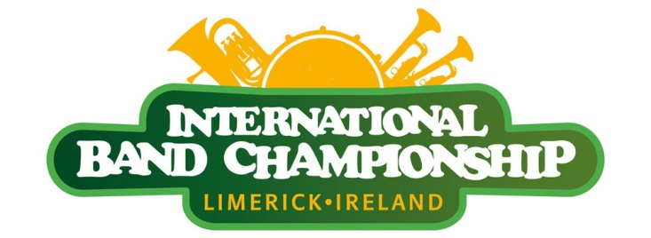
50th Limerick International Band Championship
Sunday 14th March 2021 @ 12pm
APPLICATION FORM
Name of Band :
Address:
Name of Director(s):
Website:
Telephone: Mobile:
Fax: Email:

SIZE OF BAND:
No of Musicians in Band _____
No of Majorettes/Flag Wavers _____
Total Number in Band _____

AGE GROUP:
YOUTH
( 90% of playing members under 21)
ADULT

MUSIC CATEGORY (tick one only)

Accordion
Drum & Bugle Corps
Brass
Fife & Drum
Brass & Reed
Flute & Drum
Drum Corps
Pipe & Drum

Other (Please Specify): ______________________
DIVISION (tick one only)
Home
International
Return to: Yvonne Daly Phone: +353 61 557177 or 087 6841816
Limerick City and County Council Email: Yvonne.daly@limerick.ie
Merchants Quay, Web: www.limerick.ie/stpatricksfestival
Limerick, Ireland
Closing Date for Entry: Friday 26th February 2021

