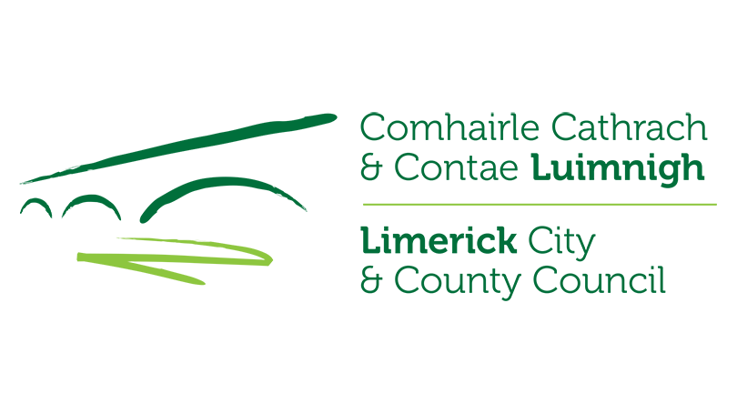

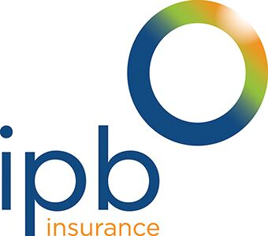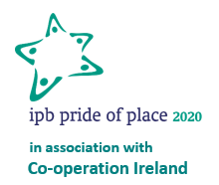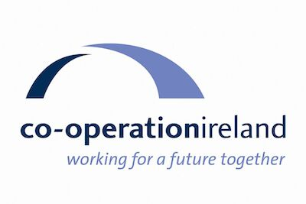

Pride of Place Competition 2020

Expressions of Interest Form

Limerick City and County Council invites expressions of interest from local community groups who wish to seek nomination to the 2020 IPB Pride of Place Competition in association with Co-operation Ireland.
Please enter the required details below:
- What competition (select either A or B) and category (select from list below relevant competition) are you interested in entering?

- Main Competition Category:
Category | Population
1 | 0-300
2 | 300 - 1,000
3 | 1,000 – 2,000
4 | 2,000 – 5,000
5 | Over 5,000
Category | Theme
6 | Creative Place Initiative
7 | Community Wellbeing Initiative
8 | Community Youth Led Initiative
9 | Community Tourism Initiative
Category | Non-Population
10 | Housing Estates
11 | Islands and Coastal Communities
12 | Urban Neighbourhoods*
*An urban neighbourhood is a defined area of a city, town or suburban place

Or

- Cities Competition Category:
Category | Population
1 | Urban Neighbourhoods under 3,000
2 | Urban Neighbourhoods over 3,000
Category | Theme
3 | Creative Place Initiative
4 | Community Wellbeing Initiative
5 | Community Climate Action Initiative
6 | Community Youth Led Initiative

- Community Group Name:

- Community Group Contact Person:
Name:

Contact Number(s):

Email Address:

- Area / Location Represented by Group: (i.e. locality/townland)

- Length of time in existence:

- Entry Summary:
To ensure that your community gets the best possible profile please take a little time to compose a summary detailing your group/ community and its activities.
Each summary (maximum 160 words) should include details of the area represented or group represented, the county, a short description of location, and a short history and details of current activities.
- Maximum 160 words written as a paragraph in the third person.
- No Lists, no personalities (named personages), no unexplained acronyms
See below 2019 example summary:
“Bornacoola is a small vibrant rural parish on the Leitrim/Longford border with a strong sense of community. It is focused around the Bornacoola Community Centre and Bornacoola GAA. Bornacoola Community Development built a community centre 25 years ago to provide a focal point and a much needed facility that is now home to the Active Age Group, the Bornacoola Drama Group, a variety of classes and other groups. Recently the centre was extended with the help of Leitrim Leader funding to provide a purpose built Youth Club (€130,000). Funding for the work of the development association comes largely from the very successful Lough Rynn Harvest Festival and Vintage Day which is now in its 23rd year. Almost everybody is involved in making this a great community event. The funds raised allows the Development Association to sponsor the Youth Club, GAA and other groups as well as maintaining the community centre and other parish public areas e.g. local cemetery -Cloonmorris.”
Please write your summary here (160 words maximum):

- Entry Photograph:
Please ensure to attach a recent photograph of your entry.

Please complete and return, preferably by email to: prideofplace@limerick.ie

Or by post to:
Pride of Place Liaison Officer
Urban and Rural Community Development Department
Limerick City and County Council
Merchant’s Quay
Limerick
V94 EH90

Closing date for receipt of expressions of interest is close of business on
Wednesday, 17th June 2020.

