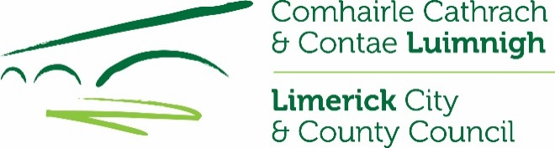
CLÁR Funding 2019
Application Form & Project Overview for
Measure 2: Support for Play Areas (including MUGA’s)
Local Authority Information - for completion by LA only
Project Name:
Indicative Priority given by LA (1-15):
Contact Person:
Correspondence Address:

GPS co-ordinates/Eircode of location of proposed works
Correspondence Email:
Correspondence Telephone No.:
Project implementation directly by the Local Development Company (LDC) (Yes/No)
Please provide contacts details, if applicable:

Local School/Community Information – for completion by Applicant
Project Name:
Contact Person:
Correspondence Address:

GPS Co-ordinates/Eircode of location of proposed works:
Correspondence Email:
Correspondence Telephone No.:

Project Information
School/Community Facility Name:
Location of proposed works, if different from above, including GPS Co-ordinates/Eircode:

DED ID Number and Name:
Are these works part of a larger project Y/N
If yes, please provide details:

Outline the nature and scope of the works:

Outline of the need and rationale for the works:

Was an application in respect of this facility approved under CLÁR in the past 3 years (Y/N)  If yes, please provide details. |  |  | Please indicate as appropriate
Has an application for funding for this project been submitted to any other scheme or programme in the past (Y/N)
If yes, please provide details.

Are all necessary permissions in place (Y/N/NA)
(Where necessary permissions are in place, please submit documentary evidence and where not in place, please provide any relevant information)
Has evidence of Ownership/Lease been provided (Y/N/NA)
Total Cost of Project: | €
Amount of Match Funding being provided by applicant under this application: (Minimum 10% of total project cost of which minimum of 5% cash contribution from the School/Community) | €
Match funding evidence attached:
(e.g. Bank statement showing balance available or similar)
Administration/Professional Fees element of funding if applicable (not more than 10% of overall project cost) | €
Amount being sought under this CLÁR application: | €
Is a full breakdown of the estimated cost attached (Y/N)
If you wish to provide any additional information in support opf this application, please complete the section below or attach separately.

I confirm that the particulars of this application are correct and that
- The project is based in a CLÁR area
- Match funding is available and ringfenced for the project
- All necessary permissions are in place
- Evidence of ownership/lease is available (if applicable)
- The facility is/will be open to the public without appointment,
- The project conforms to the the LECP and/or other local or regional plans, and
- No funding has been allocated for the same project from any other sources

Documentary evidence in support of the applicable items noted above must be submitted with the completed application

Applicant Signature: ________________________ Print Name: ________________________

Date:_________________________

Please return completed application form with supporting documentation to:

Municipal District,
Limerick City & County Council,
Newcastle West,
Co. Limerick.

By Tuesday, 16th April 2019

CLOSING DATE WILL BE STRICTLY ADHERED TO.

