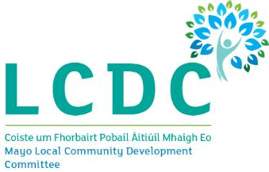
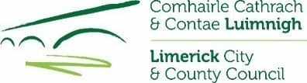
APPLICATION FORM

The Big Hello! National Community Weekend 4th – 6th May 2019

Applicant Details
Name of Community Group / Organisation:
Address of Community Group / Organisation:

Name and Contact Details of the Person Dealing with the Application
Name & Address:

Telephone & Email:
Tell us about your group:
Tell us about your event:
What will you use the funding for? Please submit evidence of costs/quotes if possible
Description of costs |  | Amount
Total |  | €
How Much Funding is your Community Group/Organisation requesting? |  | €
Is your organisation registered for VAT? |  | Yes
 |  | Organisation Tax Number:

Incomplete application forms will NOT be considered
Disclaimer – please read carefully
- The information supplied by the applicant group /organisation must be accurate and complete.
- Misinformation may lead to disqualification and/or the repayment of any grant made.
- All information provided in respect of the application for a grant will be held electronically. Limerick City & County Council reserves the right to publish a list of all grants awarded on its website.
- The Freedom of Information Act applies to all records held by Limerick City & County Council.
- The application must be signed two representatives of the organisation making the submission.
- It is the responsibility of each organisation to ensure that it has proper procedures and policies in place including appropriate insurance where relevant.
- Evidence of expenditure, receipts /invoices must be retained and provided to Limerick City & County Council/Limerick LCDC if requested.
- Limerick LCDC contribution must be publicly acknowledged in all materials associated with the purpose of the grant.
- Applications by post should use the correct value of postage stamps and allow sufficient time to ensure delivery not later than 4pm on the closing date of Thursday 4th, April 2019.

Declaration of Applicant(s)
We have read and understood the information and criteria applicable to the Fund and agree to comply in full therewith. I/we certify that all information provided in this application, and all information given in any documentation submitted in support of the application is truthful and accurate. More than 1 group member must sign the application.

Signed &

Dated:
Name: (in block capitals):

Signed &

Dated:
Name: (in block capitals):

On behalf of: (organisation's name):

Completed Applications should be returned to the Social Directorate, Urban & Rural Community Development Section, Limerick City & County Council, Corporate Headquarters, Merchants Quay, Limerick V94 EH90 or by email to limericklcdc@limerick.ie. Closing date for receipt of applications is 4pm, Thursday 4th, April 2019.

Applications received after this date will not be considered.

