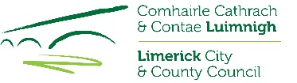
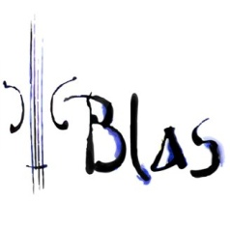
Limerick Culture & Arts Office
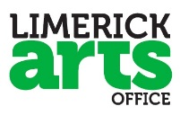
Blas International Summer School for
Traditional Irish Music and Dance

Bursary Application
(NON-RESIDENTIAL)
REF: BURS18
Blas Summer School Dates: 25 June – 6 July 2018

CLOSING DATE: FRIDAY 18 MAY 2018, 5PM

Limerick Culture & Arts Office, Limerick City and County Council, is offering one bursary to attend this year’s Blas Summer School at the Irish World Academy of Music, University of Limerick. This bursary will cover 1 weeks tuition (lectures, workshop, assessment and attendance at all concerts). The purpose of this bursary is to support artists’ professional development.

Conditions of the Bursary:

- Applicants must be resident in Limerick City and County.

- This is a non-residential bursary; all travel and/or accommodation needed are the responsibility of the successful applicant.

- Applicants must have achieved intermediate level of proficiency in their chosen area at a minimum e.g. (music/song/dance).

- Payment of the bursary will be made directly to Blas International Summer School.

- Applicants must be aged 16 years+ by 1st June 2018 (if under 18 years, written permission of parent/guardian to attend must be submitted at application stage).

- Information on traditional arts related achievements to date to be enclosed with application.

- Sample of work essential e.g. recordings or other appropriate material.

- An independent selection committee will assess applications for this bursary. Their decision will be final.

- Bursaries are awarded according to the Limerick Cultural Strategy: A Framework 2016-2030.

____________________________

For further details on the Blas Summer School 2018 programme please see: http://www.blas.ie/

For queries on submitting your bursary application to Limerick Arts Office please contact us on:
Phone: 061 557363 / 061 525031 Email: artsoffice@limerick.ie

Return form to:
Email: artsofficesubmissions@limerick.ie using the reference: BURS18
Limerick Culture & Arts Office, Limerick City and County Council, City Hall,
Merchant’s Quay, Limerick

Limerick Culture & Arts Office
Blas International Summer School for
Traditional Irish Music and Dance

Bursary Application
(NON-RESIDENTIAL)
Please note: This bursary is only open to applicants who are resident in Limerick City and County.

REF: BURS18
CLOSING DATE: FRIDAY 18 MAY 2018, 5PM

NAME OF APPLICANT:

ADDRESS:

TEL: EMAIL:

- Please tick here to opt-in for our email notifications
Please note: The processing of any personal data by Limerick City and County Council is governed by the General Data Protection Regulation (GDPR) (EU) 2016/679.​​

D.O.B: _____________
(If under 18 years, written permission of parent/guardian to attend must be submitted with application.)

Employed 3rd Level Student 2nd Level Student Other ________________

Area of Interest: Music Song Dance

Primary instrument: __________________________________

Second instrument/s: __________________________________

Samples of work included – please tick: ________________________________________

Please give details of relevant education and experience: Postgraduate / Degree / Diploma / Certificate / Other relevant courses / seminars / experiences:

Please name any organisations or individuals with whom you are involved musically (e.g. Comhaltas branch, music/dance teacher etc.)

Please outline your reasons for applying for the Blas International Summer School Bursary and how you feel you would benefit from attendance: (Attach on a separate sheet if needed)

If awarded this bursary I commit to fully attend the Blas International Summer School of Traditional Irish Music and Dance for the duration of the course supported (1 week) and to provide a short written report to the Arts Office on completion.

SIGNED: DATE:

Return form to:
Email: artsofficesubmissions@limerick.ie using the reference: BURS18
Limerick Culture & Arts Office, Limerick City and County Council, City Hall,
Merchant’s Quay, Limerick

CLOSING DATE: FRIDAY 18 MAY 2018, 5PM

