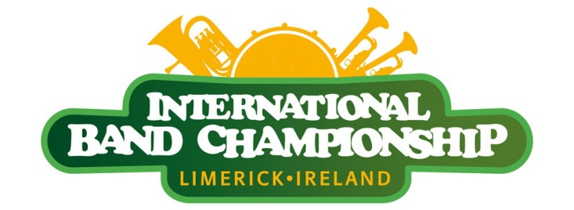

48th Limerick International Band Championship
Sunday March 18th 2018

The 48th Limerick International Band Championship will commence at 12 noon on Sunday March 18th 2018 from Pery Square.

Bands must assemble at Pery Square by 10.45am. Coaches must drop at Pery Square (to the side of the People’s Park), then continue down to Merchant’s Quay where they may park.

Each band will be assigned a co-ordinator who will assist in positioning them in the line up.

The parade route is from Pery Square, through O’Connell Street, passing the reviewing stands near the end of the route and finishing at Arthur’s Quay Park. This is where Award Presentation will be held. Prizes will be presented by the Mayor of Limerick.

Each band is required to have a banner with their name on it placed to the front of the band as they march. The band must supply banner carriers. A sign with each band name and a person to carry the sign will be provided.

Bands will be adjudicated as they march and play, all bands will be stopped as they enter the adjudication area to allow the preceding band to finish their performance. Please comply with the parade co-ordinators requirements. The band must only proceed towards the judging area when indicated by the co-ordinator.

Each band will be allowed 3 minutes performance time in front of the review stand if they wish. This is not obligatory. Immediately after the review stand, the parade route turns left into Arthur's Quay Park where there is a large performance space. Bands are requested to assemble here until the conclusion of the parade and the presentation of prizes by the Mayor.

While waiting announcement of results in the park, bands are encouraged to perform for each other and the public.

Bands must submit biographical information with their application so this can be used by the MC of the parade.

Bands are encouraged to entertain as much as possible for the large audience in attendance.

Jamboree

A Jamboree will commence once first Band enters Arthurs Quay Park after marching down through O Connell Street and past the Review Stand. All Bands will get time to play various tunes. This is a great opportunity for the public to hear more of the wonderful Bands that have entered our competition and for the other Bands to hear each other. This will continue until such time all Judges have their marking schemes complete. The atmosphere of all bands in one park is absolutely amazing.

Marking Scheme:

Each judge can award a maximum of 100 marks per band. There are two categories as set out below:
I. Music - 50 Marks This covers all aspects of a bands musical performance (Tone, quality, balance, intonation, and blend)

II. Display and Showmanship - 50 Marks This includes all aspects of the bands marching (General Effect), Drum Major, Majorettes, Colour Guard, Honour Guard

Total = 100 Marks​

Ratings:
- Superior ( A or I ) 85 points or over
- Excellent (B or II ) 74-84 points
- Good ( C or III ) 63-73 points
- Fair ( D or IV ) 50-62 points

Category Awards:
1. Overall Parade Champion:
2. Best International Band:
3. Best Youth Band:
4. Best Local Band:
5. Best Uniform:
6. Best Musical Performance:
7. Most Entertaining Performance:
8. Special Judges Award

The adjudicators may withhold any award if they are of the opinion that a minimum standard of excellence has not been achieved.

Awards Presentation

Awards will be presented directly after the parade in Arthur’s Quay Park after the Jamboree. Bands must nominate their representative to accept the award.

Each representative will be positioned at the presentation platform. Please advise all representatives that photographs will be taken of the prize giving.

